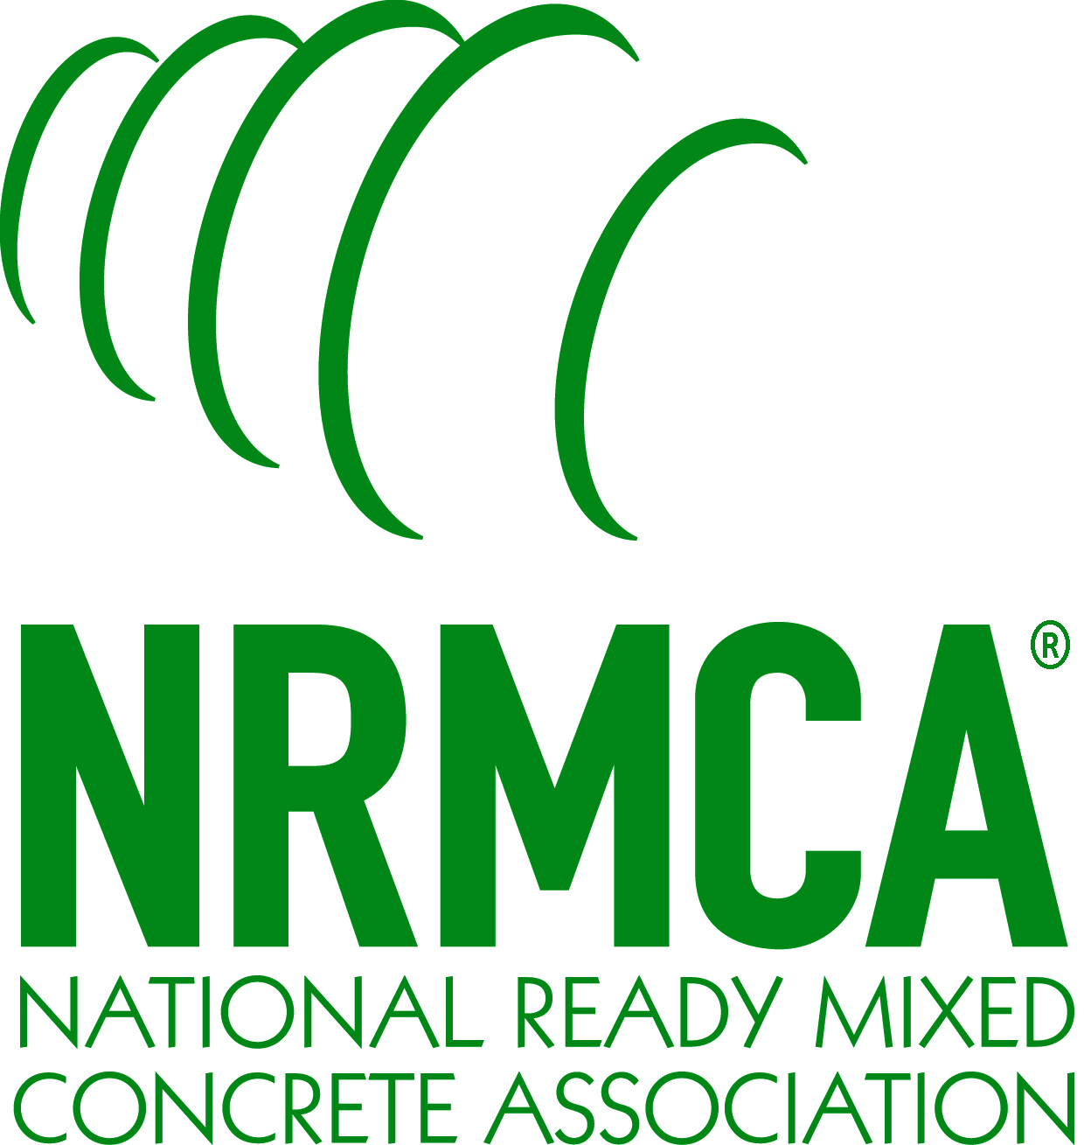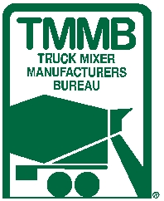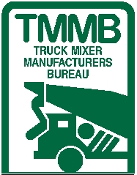 **National Ready Mixed Concrete Association**

**Call For Nominations!**

**9th Annual**

**NRMCA’s 2025 Safety Award**

**Program:**

The National Ready Mixed Concrete Association’s Annual Safety Award acknowledges the significant contribution that safety work practices gives to the growth and success of individual companies and the ready mixed concrete industry as a whole. The NRMCA Annual Safety Award is presented to an individual or company whose actions represent the very highest in the advancement of safety in the ready mixed concrete industry. The award program is generously sponsored by the *Truck Mixer Manufacturers Bureau (TMMB).*

**Award:**

The award may be presented to an individual whose single action or long-time commitment to safety and health in the ready mixed concrete industry exemplifies superior performance in the field of safety. Examples of the award winner could be a ready mixed concrete truck driver whose actions were life saving. Other examples could include plant managers, safety managers and company officials who have outstanding long-time dedication to safety and health in the ready mixed concrete industry. Other examples would be an individual’s involvement community safety activities.

This award may also recognize a corporation, coalition or organization that was unrelenting in its pursuit of safety for the industry. Nominees may have created and implemented a life-saving and or injury-preventing safety solution. Examples of the award winner could be a ready mixed concrete producer company, a ready mixed concrete state association or an industry related equipment or material supplier.

Criteria for selection of the individual or company may include evidence of the following:

• Reduction of accidents/incidents

• Demonstration of leadership in safety

• Identification, evaluation & control of hazards

• Development of safety-conscious policies & procedures

• Active promotion of safety in the workplace

• Innovation & enthusiasm in marketing safety

• Collaborative & proactive work towards improving safety

• Placing a high personal value on safety

• Mentoring of others in safety

**Award Presentation:**

The 9th Annual 2025 NRMCA Safety Award winner(s) will be honored at the awards recognition ceremony at the 2025 NRMCA’s ConcreteWorks in Orlando, FL this October.

**Nominations & Deadline:**

Nominations shall be made by submitting a detailed explanation for why the individual or company should be considered for the award. The explanation should focus on highlighting the criteria listed above. Submissions should include necessary supporting documents, a high-resolution electronic image of the nominee (if an individual), or a high resolution company logo, and any other relevant images. Please send submissions to [kwalgenbach@nrmca.org](mailto:kwalgenbach@nrmca.org). **Entries must be received via email by Friday, June 20, 2025.**

**JUDGING:**

A panel of judges assembled by NRMCA’s Safety, Environmental & Operations (SEO) Committee will judge the nominations. The panel of judges will be solely responsible for determining the award recipients and their decisions shall be final.

**More Information:**

Questions regarding the program should be directed to NRMCA’s Kevin Walgenbach at (703) 706-4857 or via email at [kwalgenbach@nrmca.org](mailto:kwalgenbach@nrmca.org).