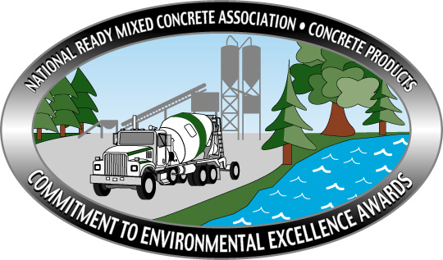

NRMCA’s 2024 Commitment
To
Environmental Excellence
Awards

Call for Entries

Purpose
The National Ready Mixed Concrete Association’s Commitment to Environmental Excellence Awards competition offers producers national recognition for outstanding contributions to protecting the environment and maintaining sound management practices in their operations. The program salutes companies that have not only met, but surpassed governmental compliance measures and demonstrated a commitment to environmental excellence through plant and staff investment.

Eligibility
Any NRMCA member company producing ready mixed concrete from a fixed plant location in the U.S., its territories, or Canada is eligible to enter. Awards will be determined upon individual plant merits. Portable plants do not qualify. First place plants from the 2023 awards program are not permitted to participate in this year’s contest but may enter again in the 2025 competition. In an effort to go “paperless”, all entries must be submitted via email.

Awards
Awards will be presented to plants who have best demonstrated environmental excellence and innovative management. Winning entrants will be honored at the Industry Awards Presentation at NRMCA‘s ConcreteWorks in October 2024. Winners will also be featured in a 2024 edition of NRMCA’s InFocus Magazine as well as Concrete Products Magazine. All entries (winners & non-winners) will receive a recognition certificate for participation in the awards program.

Judging
Entries will be reviewed by a panel consisting of individuals determined by NRMCA’s Environmental Task Group. Entries will be judged based on electronic photos with short narrative covering 10 criteria. Participants are required to submit electronic images that clearly demonstrate environmental systems and processes and at least one image that offers a broad view of the plant site. The judging will take place in early August of 2024. Entries not using this format will not be judged.

Environmental Excellence Awards
All New Entry INSTRUCTIONS

Please Follow These Instructions Below:

(Applications That Do Not Follow These Instructions Will Not Be Judged)

- Complete the entry form page completely.
- Photos should be of high resolution taken by electronic camera or smart phone.
- Narratives for each image should be no longer than 4 lines of 11 font (roughly 3-4 short sentences maximum).
- Ensure that all narratives address, first and foremost, plant-specific conditions and practices, rather than general corporate- or company-wide practices or policies.
- No more than TEN (10) photographs may be submitted with each entry. Photographs should clearly demonstrate environmental conditions, practices, systems or processes. At least one photograph should offer a broad view of the plant site. Photographs are to be submitted electronically with the application entry. Photographs may be attached or included as single individual files, or combined into one file of all photographs. Only TEN photographs may be submitted, any photographs in excess of TEN will be ignored by judges.
- Entries that do not meet these rules will NOT be considered for judging.
- The decision of the judges is final in all cases.
- All entries must be received by Friday, July 19, 2024.

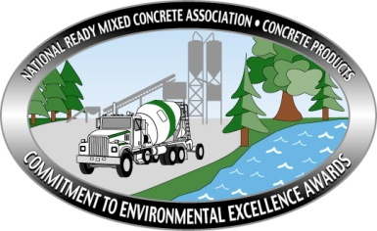
Environmental Excellence Awards
ENTRY FORM

Company Name:
Plant Name:
Plant Address:
City, State, Zip:

Entry Submitted By:
Name:
Title:
Phone:
Email:

Company Size:
Place an “X” before the appropriate category.
0-50,000 Cubic Yards
50,001-200,000 Cubic Yards
200,001 – 500,000 Cubic Yards
500,001 – 1,000,000 Cubic Yards
More Than 1,000,000 Cubic Yards
COMPLIANCE HISTORY
Age of the Plant
Number of years without Federal Violations
Number of years without State Violations
Number of years w/o County or Local Violations
Number of years without Citizen Complaints
Plant Production 2023 (cubic yards)

If any violations or complaints exist, please briefly describe them and their resolution.
Describe:

Entry Deadline Date: Friday, July 19, 2024
Return completed entry form & photos via email to Kevin Walgenbach at: kwalgenbach@nrmca.org.

QUESTIONS:
Environmental Excellence entry questions can be directed to NRMCA’s Kevin Walgenbach at kwalgenbach@nrmca.org. Participants can also download this entry form from the Association’s website: www.nrmca.org.
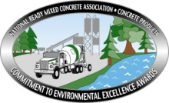
Photo Instructions:

Photo I – Site Aesthetics
Include an image that shows the plant’s aesthetic program, such as housekeeping, beautification, plant/equipment conditions, landscaping, entrance area, signage, parking areas, building condition, etc.

Describe:

Photo II – Environmental Documentation and Procedures
Include an image of the use of environmental documentation and practices, including examples such as: emergency plans, environmental job descriptions, performance measurements, environmental policy, inspection / audit program, environmental best practices, fueling and tank filling procedures, etc. Particular emphasis will be placed on programs that exhibit the use and implementation of a plant-specific Environmental Management System (EMS).

Describe:

Photo III – Environmental Training & Employee Involvement
Include an image that would illustrate the plant’s environmental training program and program for employee involvement in plant environmental operations and programs, including water quality management, returned concrete management, fuel, chemical and hazardous materials management, spill prevention, certifications, employee suggestion program, employee recognition and awards based on environmental performance, etc.

Describe:

Photo IV– Water Management
Include an image that would show your management of process water and stormwater. Particular emphasis will be placed on unique or innovative approaches to water management… activities such as process water and returned concrete recycling and reuse, process water minimization, stormwater collection and harvesting, water conservation practices.
Describe:

Photo V – Air Quality Management
Include an image that would illustrate the plant’s procedures and practices for air quality management, including (but not limited to) practices such as fugitive dust management (e.g., stockpiles, haul roads), process source emission management (e.g., water suppression, bag house/filter use, central dust collection, combustion equipment), cement unloading, air quality monitoring and inspection programs, truck / fleet / equipment emissions and idling issues, etc.

Describe:

Photo VI – Return Concrete Management
Include an image that would show your management of returned concrete, Activities such as block making, reclaimers, windrowing, re-batching.
Describe:

Photo VII – Community Relations
Include an image of your plant’s community relations program, with a particular emphasis on means of communicating your plant’s environmental program to the community and providing a means of response by the public to the plant’s environmental program. Examples of community relation programs with regards to the plant’s environmental program might include (but are not limited to): plant tours; use of website, social media, or other forms of interactive communication; community group outreach and participation; support of community and charitable organizations (even if not directly related to the plant’s environmental program), etc.

Describe:

Photo VIII – Concrete Delivery / Jobsite Activity
Include an image of your plants potential reduction for environmental impacts associated with concrete delivery and activities conducted at jobsites. Example issues might include (but are not limited to): delivery truck appearance practices; on-road spill prevention and control measures and capabilities; and jobsite chute rinse-off program and practices.

Describe:

Photo IX – Plant Sustainable Practices
Include an image that illustrates your plant’s policies and activities as they related to environmental stewardship and sustainability as implemented at the plant. Example activities to consider include (but are not limited to): carbon footprint / greenhouse gas emission reduction activities; use of supplemental cementitious materials (SCMs) to reduce carbon footprint; recycle programs (including concrete materials and process water); water conservation practices; fuel and energy use reduction strategies; support, development and promotion of “green” or environmentally innovative concrete products; innovative stormwater management or harvesting strategies; use of alternative fuels or energy sources; use of plant green space or biodiversity practices; etc.

Describe:

Photo X – An Image of Your Choosing
Allow your imagination to run and include an image of your choosing that would impress judges to your plants continued commitment to environmental excellence.

Describe:

thank you for entering the NRMCA Commitment for Environmental Excellence Award Program. Unfortunately, not all plants that enter the program receive awards. NRMCA does recognize that all plants entering the program are from the “Cream of the Crop”; THEREFORE, all plants will be receiving a certificate for submitting an entry. Should you have any questions about the program please contact NRMCA staff Kevin Walgenbach via email at kwalgenbach@nrmca.org.

Entry Deadline Date: Friday, July 19, 2024

Return completed entry form & photos via email to Kevin Walgenbach at: kwalgenbach@nrmca.org.

