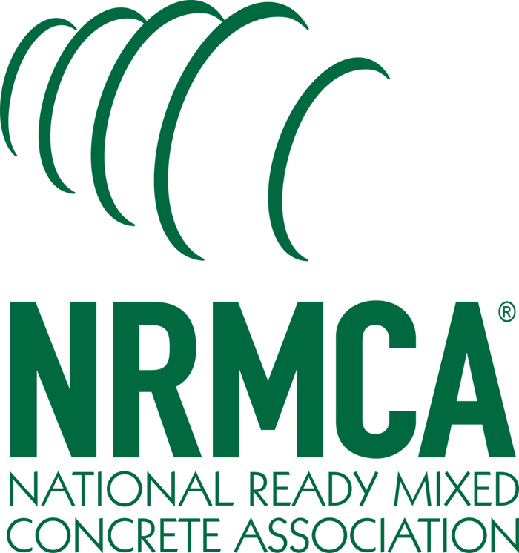

NRMCA Social Media Starter Kit

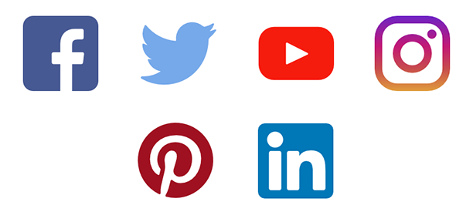
Ver. 1.1

Contents

Why should I use social media? 3

How do I get started? 4

Who is my target audience? 5

Posting Tips 5

Software/Apps 6-7

Hardware (suggested, not necessary) 7

Resources 8

Sample posts text 9-11

Sample graphics 12-16

Why should I use social media?
Simply put, social media is now part of what is commonly called “the marketing mix”. If you want to be seen, if you want your brand, your service promoted in your market area, you should be integrating social media, in some measure, into your marketing/advertising plan.

It used to be print advertising newspapers, magazines, trade journals and direct mail were the common methods of marketing to customers. Companies certainly still use those mediums, but often many publications are now just in digital format. Social media has become an effective way to be in front of your existing and potential customers every minute of every day, rather than once a month in a magazine or daily in a newspaper.

Now, with this past year’s COVID pandemic, social media has been accelerated to the forefront of business to business and business to consumer marketing. Companies are relying on various social media platforms to interact with customers that would normally be visiting brick and mortar stores.

You should consider a presence on social media if you
- Want to communicate with your existing customers
- Advertise/promote to prospective customers
- Strengthen community relationships
- Recruit personnel

Advantages of social media
- Cost- Generally, a low cost/no cost to promote to customers and prospects
- Reach- you can reach large number of customers easily and quickly
- Targeting- using particular social media platforms, you can target different demographics
- Observation- you can watch your competitors
- Relationships- develop followers for your services
- Recruitment - recruit drivers and other employee positions

How do I get started?
All companies should set up social profiles on the major social platforms, however you do not need to be active on every platform. You should focus your energy on those channels where your customers are concentrated. Start with one social media platform and grow from there.

Why establish social media accounts on all platforms?
- You don’t want another company/person to take your company name on a particular platform
- There may come a time where you might start utilizing another social channel to build your business
- When a potential customer searches for you, you want to be visible across platforms and your contact information to be available

Social Networks on Which to Establish Profiles:
- Facebook
- Twitter
- Instagram
- LinkedIn
- YouTube
- Tik Tok

Whether or not you plan on utilizing all of these social platforms, we suggest setting up
a basic profile which should include: your company name, address, logo, ‘about us’ and
contact information.

STARTER KIT TIP: When setting up your profile, try to keep your user / profile name the same across all social platforms (as much as possible within the guidelines of the channel) to keep consistency and make it easier for your customers to search for you on whatever channel they use.

Who is my audience? How do I find them?
Determine what social platforms your customers are on. If you are not sure- ask them! Or search for them on the various social platforms. Check Facebook, Instagram and LinkedIn as the primary channels. Want to recruit new employees? As a starting point, ask your existing employees what social media channels they’ve used for job hunting

Link or follow them and other related companies, suppliers, architects, builders, engineers, trade associations, etc. in the construction or concrete industry. Check the content they are posting and try to create or use content that is educational and shareable in a similar voice.

STARTER KIT TIP: At the back of this guide are some pre-written Build With Strength and Pave Ahead posts you can modify to your liking, copy, paste and post! We’ve even included suggested graphics you can use. Check out the resources page where we have links to graphics on the buildwithstrength.com web site. You can download any of these images or videos to use for your posts.

Posting Tips
Post regularly- Establish a calendar with some post ideas and start out slowly on one social media platform. You want to keep your followers (audience) engaged. Posting regularly will build interaction. Test posts at different times or days to see what posts get more engagement and reaction. It’s preferable to be on one social platform and engaging your customers and prospects consistently, rather than being haphazardly posting across all platforms.

Add another social media channel- Once you become comfortable on a particular social platform and are posting regularly, begin the same procedure on a second social platform. In time, the goal is to have a presence on all the social platforms that your customers are using. Review and monitor your posts to see what content gets the greatest engagement. Do followers enjoy video? Are they liking posts about your company employees or events that you conduct? Measure reactions to the content you post and adjust posts.

Software/Apps you can use
Photo/graphics editing apps
https://zapier.com/blog/graphic-design-tools-for-social-media-images/
- Canva
- Adobe Spark
- Adobe Lightroom
- Pablo by Buffer
- Desyner
- Snappa
- Photoshop ($$$)

Video creation & editing
- Final Cut Pro ($$$)
- iMovie
- Animoto
- Vimeo
- Adobe Premier Rush
- Movavi

Email marketing
- Mailchimp ($$)
- Constant Contact ($$)

Content Management/Scheduling: many of these resources have free trial periods and/or require no credit card to test drive their apps:
- Sprout Social all-in-one social media management
- Buffer for social media scheduling
- Hootsuite for all-in-one social media scheduling, monitoring, analytics
- Zoho social media brand management
- Hubspot Marketing, sales, and service software
- MeetEdgar automate your social media posts
- Loomly generating post ideas for social media
- Sendible for lead generation on social media
- Iconosquare manage Instagram business accounts
- Tailwind manage Pinterest & Instagram accounts

Hardware
Some suggested items, that you don’t necessarily have to have to run social media campaigns, but will certainly make your work simpler.
- Phone camera iPhone or Galaxy
- Digital camera with 2-3 lens including telephoto
- Microphone
- Tripod
- Gimbal (stabilization for video)
- External Hard drive to download large files (video and photo takes up space)
- Extra batteries
- Take along a Concrete Strongman (Max, he’s great for adding to photos)
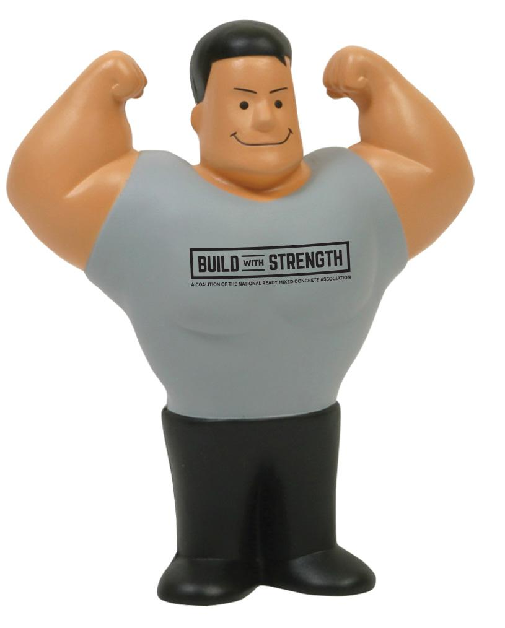
Resources
Visit the buildwithstrength.com web site for these resources:
https://www.nrmca.org/membership/social-media-graphics-library/
https://www.nrmca.org/membership/social-media-video-library/

Youtube Channels
- Build With Strength: https://www.youtube.com/channel/UCIQ3YvAhEQtIDkRhqsK5sUA/featured
- Pave Ahead: https://www.youtube.com/playlist?list=PLCA7EJaAysWPO-COIFRaPTkbyd7-wZdiz
- NRMCA: https://www.youtube.com/c/NRMCA
- NRMCA Concrete Drivers: https://www.youtube.com/user/ConcreteDrivers

Other resources:
American Concrete Institute
Global Cement & Concrete Association
Portland Cement Association
American Concrete Pumping Association
American Concrete Pavements Association
The Cement Association of Canada
Canadian Ready Mixed Concrete Association
National Ready Mixed Concrete Association
https://www.facebook.com/ConcreteCanada19
https://www.linkedin.com/company/concretecanada/
https://twitter.com/concrete_canada
https://www.brantleyagency.com/social-media-ideas-contractors/
https://zapier.com/blog/best-social-media-management-tools/
https://sproutsocial.com/insights/social-media-character-counter/
https://blog.hootsuite.com/instagram-hashtags/
https://sproutsocial.com/insights/hashtag-analytics/
https://topdogsocialmedia.com/5-things-avoid-posting-linkedin/
Starter sample posts
Starter Kit Tip:
Use a graphic from https://www.nrmca.org/membership/social-media-graphics-library/
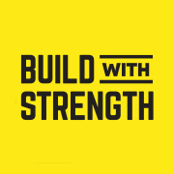
Design Center LinkedIn Post

Free concrete project design and technical assistance is available through the National Ready Mixed Concrete Association’s Concrete Design Center. The Design Center can assist you in choosing the right concrete solution for a wide variety of projects, from multi-family residential, mixed use to commercial to industrial and health care facilities.
The NRMCA’s expert team of engineers and architects are available to help you select the most appropriate concrete system for your project. In (Your State), call upon the (Put State Association or Your Company Name Here) for local support, presentations and information.
Visit: buildwithstrength.com/design-center/
https://www.youtube.com/watch?v=LLKXazvAjCI
#architects #engineers #construction #concretedesign #architecture #engineering

Concrete Fire Resilience LinkedIn Post
If you’re not building with concrete, you’re playing with fire.
Structure fires and wildfires result in significant loss of life and property in the United States each year. In addition to the direct losses of fighting fires, relocating residents and rebuilding, large fire events can cause substantial indirect losses to communities. There has been an increase in single family and multifamily structure fire losses, partly due to increased use of combustible construction methods.
The National Ready Mixed Concrete Association’s Design Center can assist you in choosing the right concrete solution for a wide variety of projects. The NRMCA’s Vice President, of Fire Codes and Standards, Shamim Rashid-Sumar can provide balanced design recommendations using both active and passive fire protection strategies. Visit the https://buildwithstrength.com/design-center/

Habitat for Humanity Twitter Post
Build With Strength is proud to partner with @Habitat_org ! Through this partnership, NRMCA members will donate concrete for at least 16 homes across the country. These homes will provide affordable, resilient & sustainable housing for hard-working families.
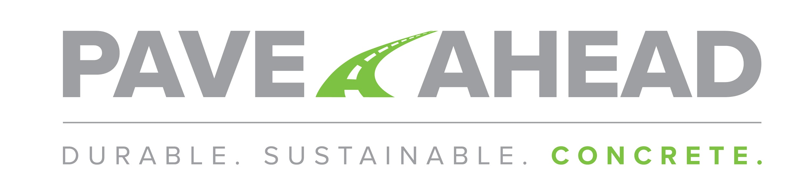

Pave Ahead LinkedIn Post

A paving project can be very complex.
The National Ready Mixed Concrete Association has made things simple with their FREE Pave Ahead Design Assistance Program which can assist you with your paving project.
Roads, bridges and critical infrastructure are vital to the transportation network and no two paving jobs are exactly alike. That’s why no two forms of concrete are exactly alike. The NRMCA has a team of experts designed to help you choose the unique form of concrete that will work best for your paving project. Your paving project assistance team will walk you through the latest paving technologies step-by-step, including CAD jointing plans. They are a diverse group of design professional engineers, technicians, and LEED certified professionals who know a lot about concrete paving. And be sure to link with NRMCA Pave Ahead team: paveahead.com
#concrete #engineers #concretepaving #concretedesign

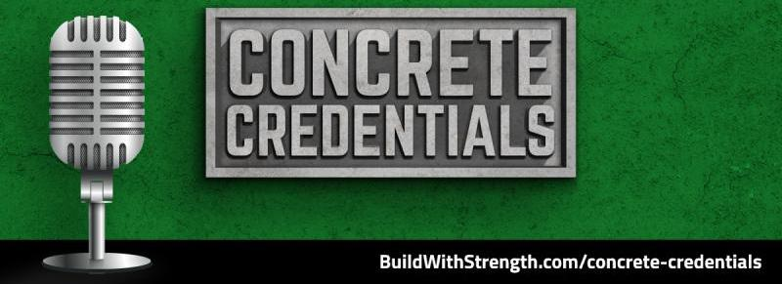
Concrete Credentials post

Be sure to check out the National Ready Mixed Concrete Association's bi-weekly podcast series, Concrete Credentials hosted by NRMCA Executive Vice President Gregg Lewis, AIA, LEED AP. Check out Gregg's podcasts here: https://buildwithstrength.com/concrete-credentials/

Gregg talks with industry experts from the design, development, construction, and supply industries who understand the many benefits of using concrete. And Gregg covers the topics- be it concrete’s strength, durability and resilience, aesthetic quality, sustainability and performance benefits, ease of use, or cost-effectiveness. The industry agrees that concrete is the material of choice for buildings, paving, and infrastructure.

Check out Gregg's podcasts here: https://buildwithstrength.com/concrete-credentials/
Or search your favorite podcast resource Apple iTunes, Spotify, etc. to download them.
Be sure to give a listen!
#concretecredentials

Starter Kit Tip: Remember … social media is still … SOCIAL! Some of your posts can be general-interest related to your community, your business culture & values, industry fun and more.

Here are some images you can simply copy and paste as posts:

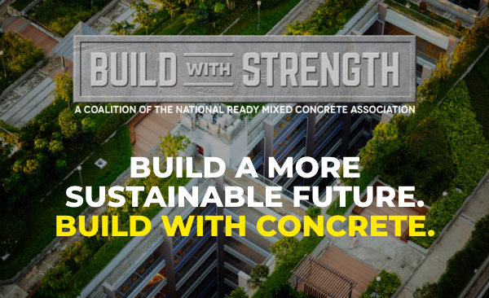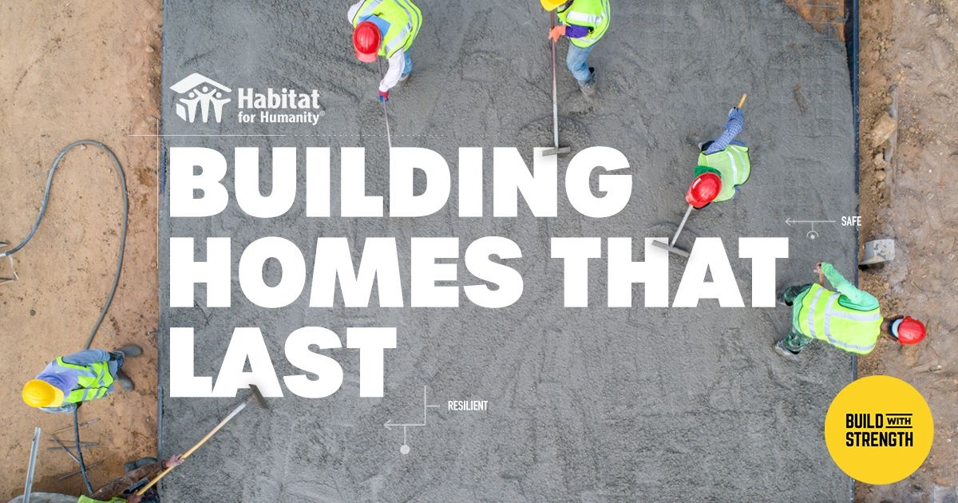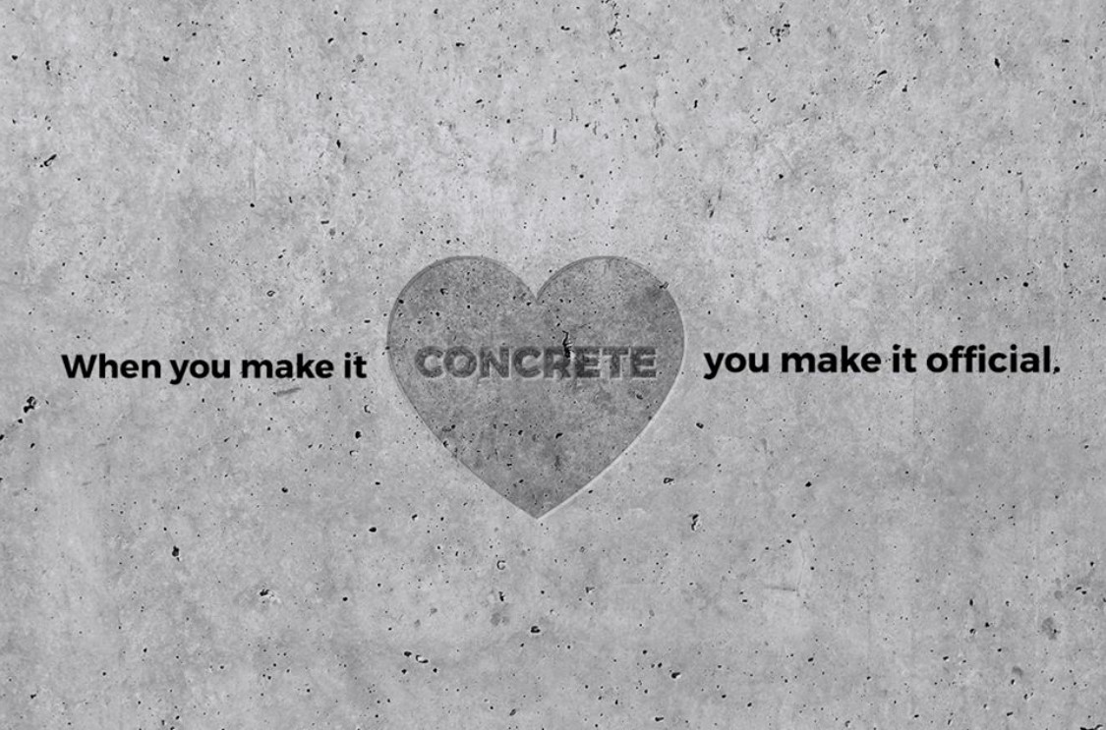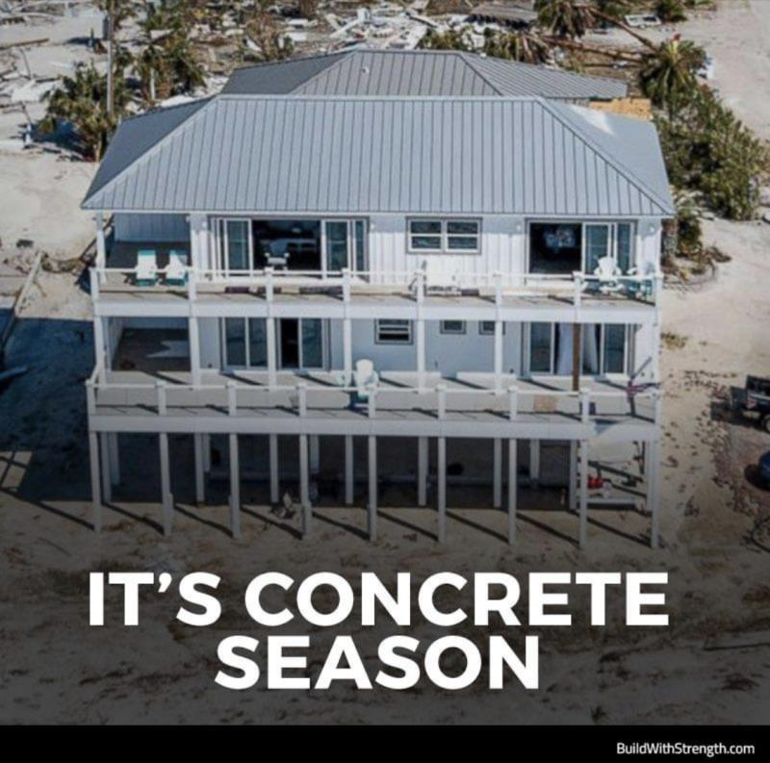
Some sample post ideas. Think Projects, People (Employees), Events (Holidays, construction industry related events, your own company events, etc.)

