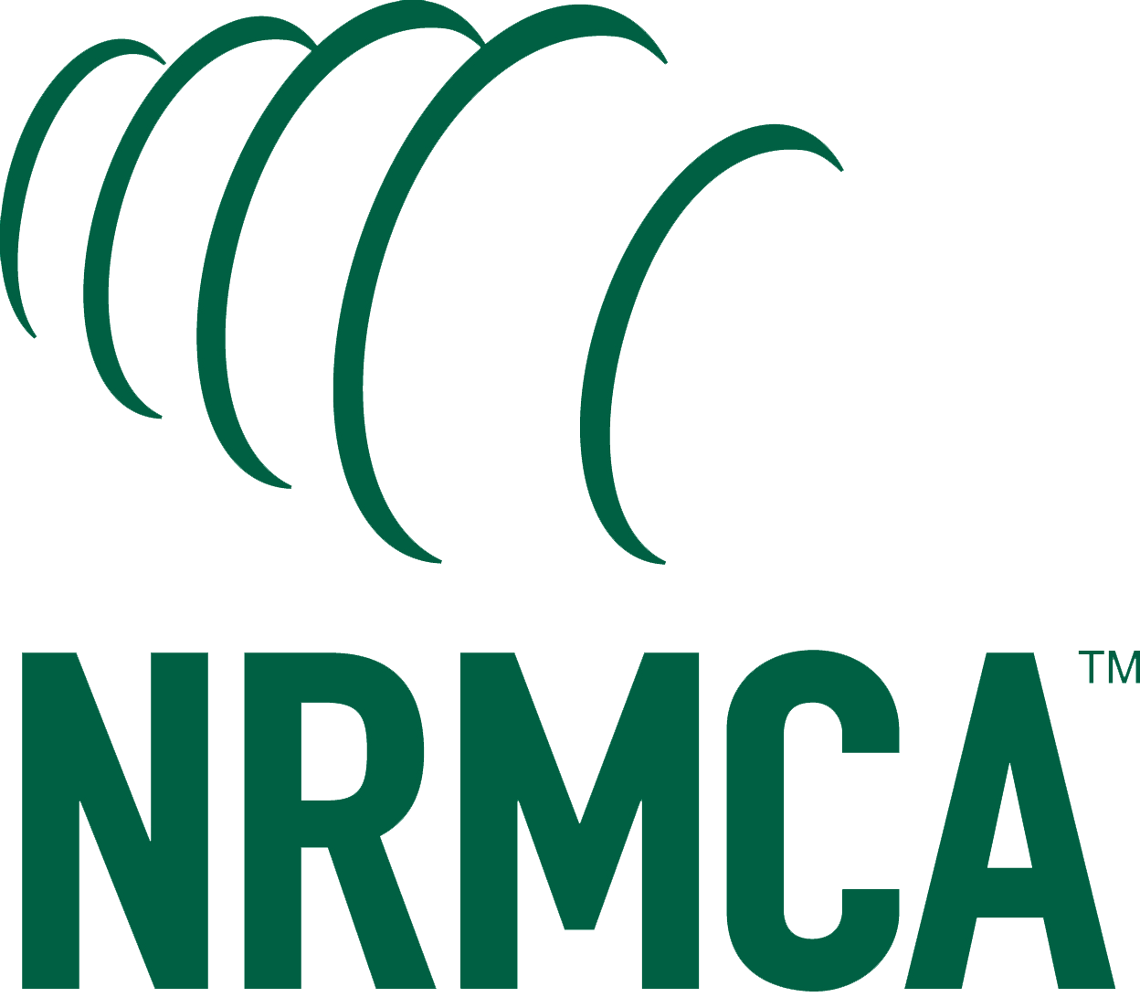
2022 NRMCA
State Association of the Year Award

NOMINATION FORM

Award Overview:

This is an annual NRMCA award for the state ready mixed concrete association making significant progress for the ready mixed concrete industry. Each entry should include up to five of your current (within the last 3 years) programs or initiatives that exemplify your organization’s best work on behalf of the concrete industry. Additionally, each entry should include your organization’s involvement (within the last 12 months) with NRMCA. The award will be presented at the 2023 NRMCA Annual Convention. We encourage the winning state executive as well as his/her elected official to attend and receive the award. Winner will be posted on NRMCA’s Website, in E-News and Concrete InFocus, as well as in a press release to the industry.

Only one award will be presented each year. Applicants will be asked to provide budget size, number of members, and number of staff – these items will allow the judges to review each entry in light of the resources available.

There is a maximum limit to the amount of materials submitted. You will be asked to provide your materials electronically.

Nomination Criteria:

1. The person making the nomination may be the State Association Executive or one of the association’s members. If the executive is completing the nomination, he/she must have an endorsement of the application by one of the state association’s member representatives.
2. The nominee must be a state or area ready mixed concrete association. The nominee may have other areas, including aggregate or construction, as part of its function. Prior winners are eligible to participate.
3. As with most recognition awards, the more detailed information you can provide, the better. However, materials submitted should be limited to 1,000 words and 5 pieces of sample materials per subject.
4. You must submit your entry materials electronically in a “standard” office (Word or PDF) format, as a SINGLE file which is of a size that can be conveniently emailed to the judges (less than 10MB), and/or as a link to an on-line entry, which would be provided to the judges.

Return Application to:
State Association of the Year Award
c/o Nicole Maher, NRMCA
Email: nmaher@nrmca.org

Deadline for Submission: January 4, 2023

State Association ________________________________________________________________

Address ________________________________________________________________

City/State/Zip ________________________________________________________________

Country ________________________________________________________________

Phone _______________________________Fax ____________________________

Web Site ________________________________________________________________

Name of Executive ________________________________________________________________

Title ________________________________________________________________

Email ________________________________________________________________

Association Provides Support in □ Promotion □ Education □ Innovative Thinking
(check all that apply) □ Advocacy □ Research □ Other

2022 Budget (Total) $__________________ Number of Staff ________________

# of Members (Total) ___________________

Person Making Nomination __________________________________________________________

Company ________________________________________________________________

Address ________________________________________________________________

City/State/Zip ________________________________________________________________

Country ________________________________________________________________

Phone _______________________________Fax ____________________________
Please provide detailed information on up to five programs or initiatives developed and implemented by this state association in the last 36 months.

PROGRAM #1: ________________________________________________

Maximum 1000 words, plus 5 samples of materials.

PROGRAM #2: ________________________________________________

Maximum 1000 words, plus 5 samples of materials.

PROGRAM #3: ________________________________________________

Maximum 1000 words, plus 5 samples of materials.

PROGRAM #4: ________________________________________________

Maximum 1000 words, plus 5 samples of materials.

PROGRAM #5: ________________________________________________

Maximum 1000 words, plus 5 samples of materials.

Involvement with NRMCA

Please tell us below any ways your association is involved with NRMCA and its programs and activities. Information and materials should reflect programs or products implemented or actively in use in the last 12 months. Maximum 1000 words, plus 5 samples of materials.

