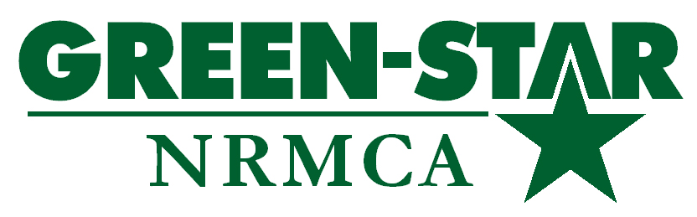
Attachment C:

NRMCA Green-Star Plant Certification Application

Date of Application:

Initial Application

Renewal Application Plant ID#: Cert ID#:

THIS APPLICATION HAS BEEN SUBMITTED ON BEHALF OF THE FOLLOWING NRMCA MEMBER PLANT FACILITY:

Applicant Company Name:
Applicant Plant Facility Name:
Plant Facility Street Address:
City: State: Zip-Code:
Plant Facility Office Number: Plant Facility Fax Number:

THIS APPLICATION HAS BEEN APPROVED BY THE FOLLOWING NRMCA ACCREDITED GREEN-STAR AUDITOR:

Accredited NRMCA Green-Star Auditor Number:
Auditor Name: Company Name:
Street Address:
City: State: Zip-Code:
Office Number: Fax Number:
E-Mail Address: Website:

I, as an NRMCA Accredited Green-Star Auditor, have visited this facility and confirm it meets all of the following Green-Star requirements:

This facility is an NRMCA member facility in good standing, as proven by inspection of current year membership confirmation. (Do Not Check Box for Non-NRMCA Members)

This facility has an EMS that contains all of the following components (provide description where indicated):

The EMS must include an environmental policy statement that includes a documented policy regarding continual improvement, pollution prevention, and compliance with all applicable environmental regulations and rules.

The EMS must include a program for continual improvement in key environmental areas of concern to the concrete industry, as described in this document. This program for continual improvement must begin and end across one EMS cycle, at which point it must begin again. This program for continual improvement must include an identification of key environmental aspects and impacts, including, but not limited to. (As Indicated Check All That Apply):

Water Quality Management (process water discharges, stormwater discharges, water conservation, reuse and recycling)

Air Quality Management (airborne process emissions, airborne fugitive emissions, vehicular emissions)

Hazardous Materials Management (petroleum and chemical use, fuel consumption, petroleum and chemical spill / leak prevention, SPCC)

Solid Material Management (returned concrete management, concrete fines, stone and sand)

Community Issues (noise and aesthetic conditions)

Sustainability (energy conservation, recycling efforts, pervious concrete)

Describe the program for continual improvement as presented in the EMS, including length of each cycle, and dates of cycles completed as of the date of the application (MUST be a minimum of one cycle of 3 months after the initial environmental baseline (Gap Analysis) has been completed (although longer durations, of at least 6 months, are strongly advised).
Describe:

Measures to document current performance levels present at the start of the EMS cycle (quantitatively where appropriate).
Describe:

The identification of measurable goals (where appropriate) designed to provide a greater level of performance at the end of the EMS cycle than at present.
Describe:

A description of a program to meet those goals by the end of the EMS cycle, (i.e.,. an identification of specific practices and activities that will be attempted to meet the stated goals).
Describe:

A means to measure and document performance levels present at the end of the EMS cycle, and a process to identify the results obtained and whether the stated goals have or have not been met (and if not, an attempt to explain why the goals were not met).
Describe:

A Self-Evaluation Program to gauge regulatory compliance level and environmental operational status. Use of a regular documented audit program, either by the facility itself or through a third-party auditing program, is preferential. While any comprehensive, documented, regular self-evaluation or audit procedure, protocol or documentation is acceptable; it must be deemed satisfactory to the Accredited Auditor. Said self-evaluation or auditing procedure must be comprehensive, regular, and documented.
Describe Self-Evaluation Program:

A Comprehensive Environmental Training Program for key personnel, with an emphasis on appropriate NRMCA’s training courses or equivalent for appropriate personnel. This would include, but not be limited to:
    - NRMCA Environmental Certification Course
    - NRMCA Plant Manager’s Certification Course
    - Certified Driver Professional (CDP) Course
    - Company-specific environmental training, to be conducted on a regular basis
    - Facility-specific environmental training, to be conducted on a regular basis
    - A discussion of measures employed as part of this training to gauge understanding and comprehension should be included (e.g., written testing, oral testing, performance evaluations, etc.).
Describe the facilities environmental training program:

Demonstration of adequate staffing and management team committed to implement and support the EMS Cycle at the concrete plant facility. This must include an identification of the key personnel directly involved with the EMS program at the concrete plant facility, as well as their specific duties and responsibilities, as well as a statement confirming the commitment (including personnel and funding as appropriate) on the part of corporate management to the implementation and maintenance of the EMS program.
Describe the facilities program for staffing and management commitment:
A public outreach program, with which the facility can interact with the community on issues of environmental relevance to a degree deemed appropriate to the facility in question.
Describe:
*List of Ready Mixed Concrete Environmental Best Industry Practices that have not been described elsewhere. (* = Benchmarking items only and will not factor into Green-Star Certification at this time.)
Describe:
*List of any other carbon footprint voluntary reductions (i.e., using biodiesel, using low-sulfur diesel in plant boilers, buying wind and solar power, tree planting, etc.). (* = Benchmarking items only and will not factor into Green-Star Certification at this time.)
Describe:

Certifications:

Company Official

On behalf of the applicant facility, and as a company representative of the applicant facility company, I hereby certify that the statements made in this application are true, accurate and complete, and that this facility meets the requirements for NRMCA Green-Star Certification. This facility will be maintained in conformance to the requirements of the NRMCA Green-Star Certification for the duration that it is valid.

Company Official Signature: ___________________________________________________

Company Official Printed Name: Company Official Title:

Date:

NRMCA Accredited Green-Star Auditor

As the NRMCA Accredited Green-Star Auditor who has reviewed the requirements of the Green-Star program and the EMS program of the applicant facility, I hereby certify that the statements made in this application are true, accurate and complete, and that this facility meets the requirements for NRMCA Green-Star Certification.

Auditor Signature: __________________________________________________

Auditor Printed Name:

NRMCA Green-Star Auditor Number:

Date:

